Create a Virtual Firewall (Security Group)
In the cloud, an "Architect" defines the rules. You will:
- Navigate to the EC2 Dashboard in AWS.
- Click on Security Groups → Create Security Group.
- The Architecture Rule: Set an "Inbound Rule" that only allows traffic on Port 22 (SSH) from your specific IP address. This ensures only you can "enter" the server.
- Add another rule for Port 80 (HTTP) to allow the public to see your website, but nothing else.
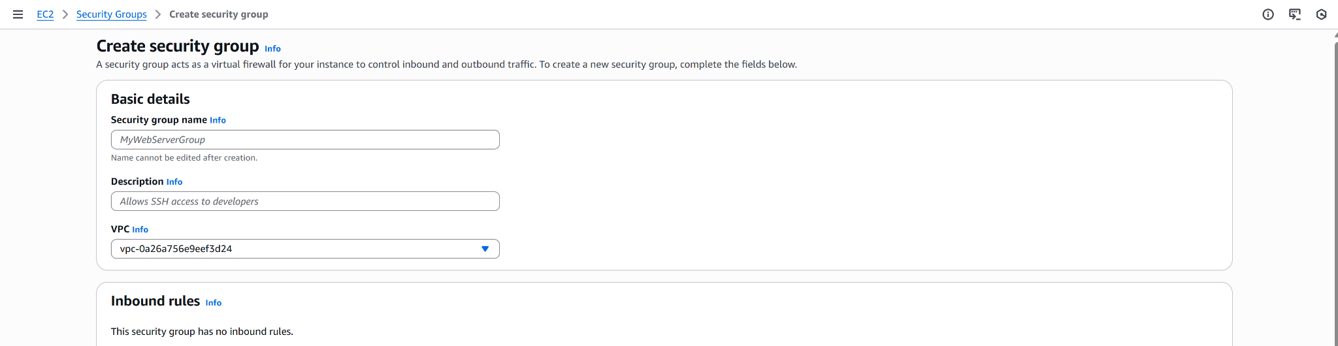
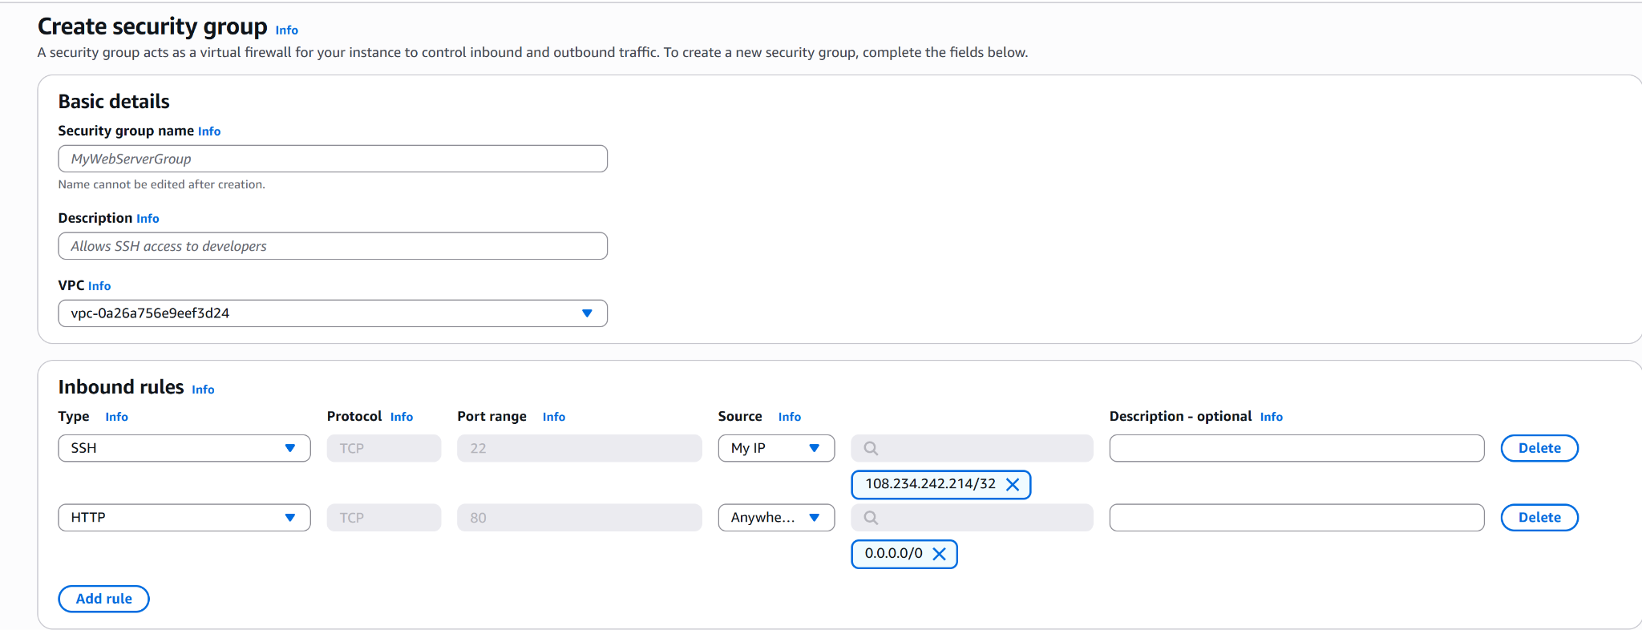

Step 3: Generate the Key Pair
- Under the Network & Security tab, click Key Pairs.
- Create a new pair (RSA) and download the .pem file. This is your "Master Key." Never share this or upload it to a public GitHub.
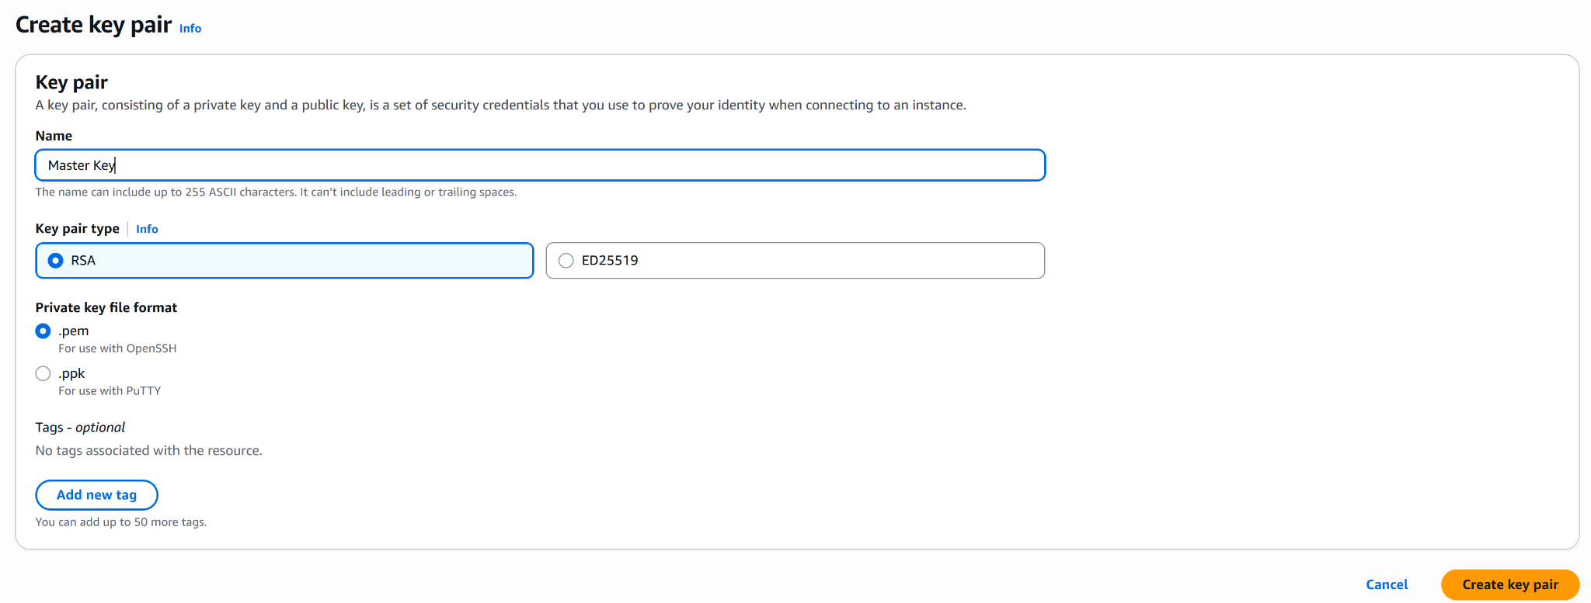

Step 4: Launch and Verify
- Launch a t2.micro instance (Free Tier).
- Attach the Security Group you made in Step 2.
- Try to connect via SSH. If you can enter but others can't, your "architecture" is working!
